

|  |  |
| --- | --- |
| March 17, 2020 at 16:46:56 (UTC). | to legitimately share published articles. |
| Downloaded via UNIV OF MICHIGAN ANN ARBOR on | See https://pubs.acs.org/sharingguidelines for options on how |

 Cite This: [ACS Energy Lett. 2018, 3, 1192−1197](http://pubs.acs.org/action/showCitFormats?doi=10.1021/acsenergylett.8b00548)



Curtailing Perovskite Processing Limitations via Lamination at the Perovskite/Perovskite Interface

Sean P. Dunfield,†,‡,§ David T. Moore,† Talysa R. Klein,† David M. Fabian,†,# Jeﬀrey A. Christians,† Alex G. Dixon,†,‡ Benjia Dou,†,⊥ Shane Ardo,#,∇ Matthew C. Beard,† Sean E. Shaheen,‡,∥,⊥ Joseph J. Berry,*,†,‡,∥ and Maikel F. A. M. van Hest*,†

†National Renewable Energy Laboratory, Golden, Colorado 80401, United States

‡Renewable and Sustainable Energy Institute, University of Colorado Boulder, Boulder, Colorado 80309, United States §Materials Science & Engineering Program, University of Colorado Boulder, Boulder, Colorado 80309, United States ∥Department of Physics, University of Colorado Boulder, Boulder, Colorado 80309, United States

⊥Department of Electrical, Computer and Energy Engineering, University of Colorado Boulder, Boulder, Colorado 80309, United States

#Department of Chemistry, University of California Irvine, Irvine, California 92697, United States

∇Department of Chemical Engineering and Materials Science, University of California Irvine, Irvine, California 92697, United States

*S Supporting Information

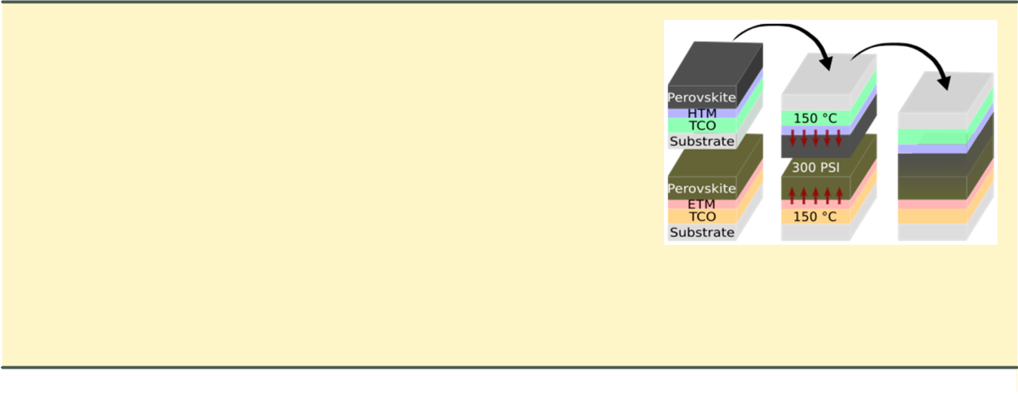

ABSTRACT: Standard layer-by-layer solution processing methods constrain lead−halide perovskite device architectures. The layer below the perovskite must be robust to the strong organic solvents used to form the perovskite while the layer above has a limited thermal budget and must be processed in nonpolar solvents to prevent perovskite degradation. To circumvent these limitations, we developed a procedure where two transparent conductive oxide/transport material/perovskite half stacks are independently fabricated and then laminated together at the perovskite/perovskite interface. Using ultraviolet−visible absorption spectroscopy, external quantum eﬃciency, X-ray diﬀraction, and time-resolved photoluminesence spectroscopy, we show that this procedure improves photovoltaic properties of the perovskite layer.

Applying this procedure, semitransparent devices employing two high-temperature oxide transport layers were fabricated, which realized an average eﬃciency of 9.6% (maximum: 10.6%) despite series resistance limitations from the substrate design. Overall, the developed lamination procedure curtails processing constraints, enables new device designs, and aﬀords new opportunities for optimization.

|  |
| --- |
| Letter |



Since emerging as a viable material for use in photovoltaic devices in 2009, lead−halide perovskites have attracted an enormous amount of attention due to their near-ideal

photovoltaic properties1 and low-temperature solution-based fabrication.2,3 Process and composition optimization has spearheaded advancements in material stability4 and led to an unprecedented rise in eﬃciency from 3.85 to 22.6%6 in just 8 years. Despite their excellent performance, many aspects of these devices need further investigation due to the complex interplay between the perovskite layer and other device material layers that impacts the details of their formation7−10 and resulting device behavior.11,12 Gaining a fundamental under-standing of these matters will be essential in progressing from material stability to device stability and reducing nonradiative losses in photovoltage.13,14 Nonetheless, these topics have not been adequately studied, in large part because standard solution



deposition methods15,16 create solvent compatibility issues and thermal budgeting constraints that limit the materials and architectures that can be applied in devices; for example, most metal oxides cannot be deposited on top of the perovskite layer using conventional solution processing.17 The use of a lamination procedure in which two independently processed perovskite half stacks are laminated together circumvents a number of these process limitations and can be applied to a wide range of materials used in perovskite optoelectronic devices.18 This work focuses on the development of such a lamination procedure, evaluation of its impact on the structural,

Received: April 6, 2018

Accepted: April 24, 2018

Published: April 24, 2018

|  |  |  |
| --- | --- | --- |
| © 2018 American Chemical Society | 1192 | DOI: [10.1021/acsenergylett.8b00548](http://dx.doi.org/10.1021/acsenergylett.8b00548) |
|  |  | ACS Energy Lett. 2018, 3, 1192−1197 |



formulation utilized produces films with a low root-mean-square surface roughness of 9.63 and 9.44 nm on SnOx and NiOx, respectivley ([Figure S3](http://pubs.acs.org/doi/suppl/10.1021/acsenergylett.8b00548/suppl_file/nz8b00548_si_001.pdf)).16 Additionally, these films are of high quality, as evidenced by their performance in standard device architectures ([Figure S7](http://pubs.acs.org/doi/suppl/10.1021/acsenergylett.8b00548/suppl_file/nz8b00548_si_001.pdf)).

Once optimized, the half stacks were laminated together using a hot press at ∼300 psi and 150 °C for 20 min, as described in the Supporting Information ([SI](http://pubs.acs.org/doi/suppl/10.1021/acsenergylett.8b00548/suppl_file/nz8b00548_si_001.pdf)). To gauge the eﬀect of lamination on the perovskite active layer, a series of analyses were conducted including UV−visible absorption

Figure 1. PbI2 (001) [2θ = 12.8°] and MAPI (110) [2θ = 14.2°] XRD peaks for MAPI thin films on smooth SnOx and NiOx as a function of perovskite annealing time.

Note that, while the reaction above is reversible and occurs at temperatures as low as 100 °C, two of the three reaction products are capable of oﬀ-gassing in standard geometry, driving the reaction forward as predicted by Le Chatelier’s Principle. In contrast, the lamination process utilized here should encapsulate the products formed in thermal decom-position between the two glass substrates, balancing eq 1 and preventing it from proceeding. By forming a smooth charge transport layer, utilizing a MAPI solution with an optimized MAI to PbI2 ratio, and annealing the resulting perovskite for at least 15 min at 100 °C, MAPI films with little to no crystalline PbI2 were successfully produced on both SnOx and NiOx (Figure 1). These films should be ideal for lamination as the

CH3NH3PbI3(s) + heat

optical, photophysical, and electronic properties of the perovskite layer, and demonstration of its ability to produce functioning devices. To establish and optimize processing conditions, a tin oxide (SnOx) electron transport material (ETM), nickel oxide (NiOx) hole transport material (HTM), fluorine-doped tin oxide (FTO)-coated glass substrates, and two methylammonium lead triiodide (CH3NH3PbI3, MAPI) perovskite active layers are utilized.

Due to the complex interplay between the perovskite and other device material layers, minor changes in substrate preparation, solution stoichiometry, deposition parameters, and annealing conditions have been shown to alter film formation and composition,9,19−22 such as the amount of lead iodide (PbI2) present in films. Using the CH3NH3PbI3 (110) and PbI2 (001) peak area ratios obtained from powder X-ray diﬀraction (XRD), the ratio of CH3NH3PbI3 to PbI2 in each half stack was maximized so that the presence of PbI2 could be used as an indicator of the following thermal degradation pathway22−26 in laminated devices:

ACS Energy Letters

Letter

spectroscopy, external quantum eﬃciency (EQE), XRD, and time-resolved photoluminesence spectroscopy (TRPL).

Absorption spectra were obtained for FTO/SnOx or NiOx/ MAPI half stacks, laminated samples, delaminated samples, and FTO/SnOx or NiOx references using the transmission and reflection spectra calculated from data acquired using an integrating sphere. To account for varying perovskite and glass thickness while maintaining the shape and location of the band edge, curves were linearly normalized as described in the [SI](http://pubs.acs.org/doi/suppl/10.1021/acsenergylett.8b00548/suppl_file/nz8b00548_si_001.pdf). As shown in Figure 2a, the absorption data indicates that lamination decreases the band gap of the perovskite and maintains or sharpens the features at the absorption band edge, corresponding to modification of the conduction and/or valence band edge structures and associated defects.27 Subsequent delamination at the SnOx/MAPI interface (described in the [SI](http://pubs.acs.org/doi/suppl/10.1021/acsenergylett.8b00548/suppl_file/nz8b00548_si_001.pdf)) appears to further reduce the band gap of the perovskite and partially revert the shape of the band edge back to its prelaminated form. Consequently, delaminated samples should serve as a reasonable qualitative metric for the eﬀects of lamination.

Changes in absorption were confirmed using EQE measure-

⇌ CH3NH 2 (g) + HI(g) + PbI 2 (s) (1) ments on a FTO/SnOx/laminated MAPI/NiOx/FTO device and a control FTO/SnOx/MAPI/spiro-OMeTAD/MoOx/Al

device fabricated without lamination, as described in the [SI](http://pubs.acs.org/doi/suppl/10.1021/acsenergylett.8b00548/suppl_file/nz8b00548_si_001.pdf). To compare the shape of the EQE band edges, spectra were again normalized as above. The red shift measured with EQE, shown in Figure 2b, agrees with that of the absorption measurements within the resolution of the instrument (∼5 nm). To ascertain what extent the changes in the optical spectra correlate to structural changes induced by the lamination process, prelaminated half stacks fabricated with typical annealing conditions, prelaminated half stacks with additional thermal annealing, and delaminated half stacks were analyzed via XRD. Results, shown normalized to the most intense peak for clarity in Figure 2c,d, display three main trends for the laminated devices: a decrease in the full width at half-maximum of all peaks attributed to MAPI, an increase in the MAPI(220) to MAPI(210) ratio, and an invariance in the PbI2(001) to MAPI(110) ratio. Note that improvements of similar magnitude are not seen in devices with additional thermal input. This suggests that something particular aﬀorded by lamination and successive delamination results in increased crystallinity and an orientation of domains to favor the (110) crystal orientiation with no detectable thermal decomposition. Although measured on delaminated stacks, the results are consistent with other measurements, providing evidence that changes to the electronic structure arise in part by a change in morphology.

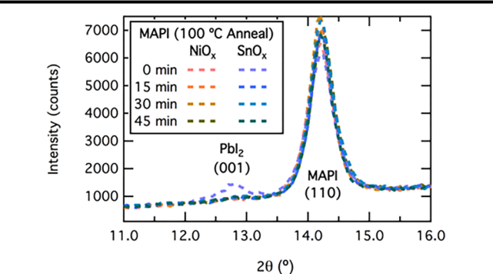

To correlate these optical and morphological changes to a functional property of the photovoltage, TRPL was conducted on glass/MAPI samples, glass/laminated MAPI/glass samples, and glass/delaminated MAPI samples. As lifetimes are known to correlate with excitation intensity,28 analysis was conducted using 450 nm wavelength excitation through the glass face of each sample with constant excitation fluence. While the glass backside of the laminated sample certainly results in varied amounts of attenuation and scattering, all perturbations were intensity-independent and therefore should not aﬀect the lifetime. Despite optimal sample orientation and constant fluence, variations in the density of free charge carriers generated during excitation are expected due to the diﬀerences observed in absorption. Although lifetimes at shorter time scales are heavily perturbed by complex free-carrier-density-

|  |  |
| --- | --- |
| 1193 | DOI: [10.1021/acsenergylett.8b00548](http://dx.doi.org/10.1021/acsenergylett.8b00548) |
|  | ACS Energy Lett. 2018, 3, 1192−1197 |



ACS Energy Letters Letter

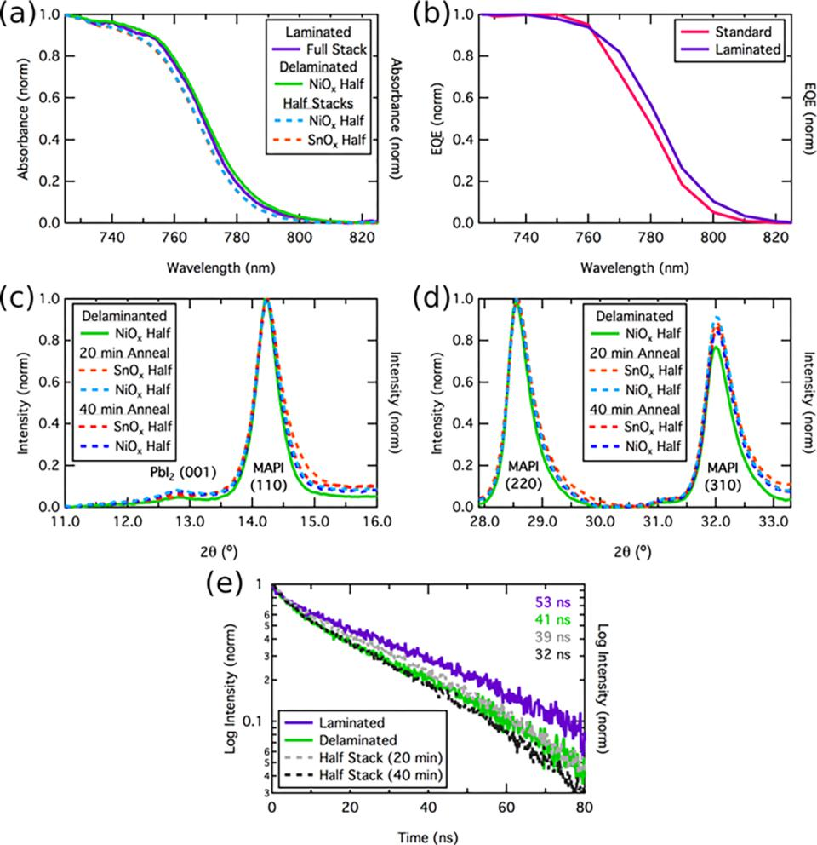

Figure 2. Characterization of prelaminated half stacks, laminated stacks, and delaminated stacks used to gauge the eﬀects of lamination, including (a) absorbance spectroscopy, (b) EQE, (c) XRD of PbI2(001) and MAPI(110) peaks, (d) X-ray diﬀraction of MAPI (220) and (310) peaks, and (e) time-resolved photoluminescence spectroscopy.

dependent eﬀects, such as band gap renormalization29 and bimolecular recombination,30 longer time scales where trap-mediated recombination processes dominate recombination kinetics are expected to have smaller intensity dependence. Consequently, the logarithm of the intensity is highly linear after the initial several nanoseconds, as shown in Figure 2e. To account for this, data was truncated for fitting to exclude points prior to 20 ns, such that a single-exponential fit produces small residuals ([Figures S5 and S6](http://pubs.acs.org/doi/suppl/10.1021/acsenergylett.8b00548/suppl_file/nz8b00548_si_001.pdf)). Results show that laminated samples exhibit longer carrier lifetimes of ∼53 ns, compared to ∼41 ns for the delaminated device, ∼39 ns for the prelaminated device with normal thermal input, and ∼32 ns for the prelaminated device with additional thermal input.

Together, the observed narrowing of the XRD peaks, red shift of the absorption and EQE data, and the increase in photoluminescence lifetime suggest that lamination beneficially alters the material quality of the perovskite layer, likley by reducing the concentration of defects and improving the charge-carrier dynamics. Although the improvement in electronic properties is clear, further investigation is underway to ascertain what extent these improvements are due to better structure, stoichiometry, and passivation at the surfaces/ interfaces.

To demonstrate the newfound flexibility in device architectures aﬀorded by lamination, devices were fabricated that feature all-oxide transport layers (SnOx/MAPI/NiOx), an architecture that is generally inaccessable by conventional solution processing methods. Detailed optimization of substrate design and charge-transport layers was beyond the scope of this study; therefore, a simple substrate design (shown qualitatively in Figure 3a and with dimensions in [Figure S1](http://pubs.acs.org/doi/suppl/10.1021/acsenergylett.8b00548/suppl_file/nz8b00548_si_001.pdf)) was adopted. TEC 15 FTO substrates were patterned via laser scribing, coated with either NiOx or SnOx and perovskite, and laminated as described in the [SI](http://pubs.acs.org/doi/suppl/10.1021/acsenergylett.8b00548/suppl_file/nz8b00548_si_001.pdf), resulting in ∼25 mm2 semitransparent devices with a nonoptimal ∼800 nm thick MAPI active layer. The average device demonstrated a power conversion eﬃciency (PCE) of 9.6%, open-circuit voltage (Voc) of 950 mV, short-circuit current density (Jsc) of 20.2 mA/cm2, fill factor (FF) of 50.0%, shunt resistance (Rsh) of 1044 Ω, and series resistance (Rs) of 59 Ω. The J−V curve and corresponding parameters of the champion device are shown in Figure 3b. While these devices realize PCEs that are not competitive with standard processing, the predominant eﬃciency loss can be attributed to the Rs (∼59 Ω), which is much larger than that observed in devices that utilize a geometrically well-designed architecture (<5 Ω). This high Rs, which is responsible for losses in measured voltages and thus has a detrimental impact on the FF,

|  |  |
| --- | --- |
| 1194 | DOI: [10.1021/acsenergylett.8b00548](http://dx.doi.org/10.1021/acsenergylett.8b00548) |
|  | ACS Energy Lett. 2018, 3, 1192−1197 |



ACS Energy Letters Letter

Figure 3. (a) Device TCO architecture utilized to create devices (b) and champion device J−V curve and corresponding parameters.

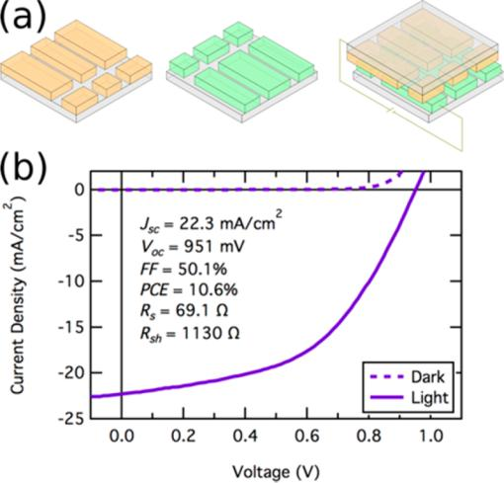

is caused by the architecture utilized to facilitate the lamination process rather than the impact of lamination on the active layer itself. Namely, the use of two oﬀset substrates with TCO pads causes the extracted current to flow an extra distance of at least 7.5 mm through a 5.0 or 6.5 mm wide TCO on each side, where major resistive losses of ∼40 Ω occur (15 Ω/square). Reducing Rs by using thicker TCO layers, a shorter distance from the active area to charge collection area, bus bars, or another strategy should drastically improve the measured PCE.

It is evident that a combination of pressure and heat is capable of bonding the two perovskite thin films together. Devices made using this method perform at reasonable eﬃciency in the primitive device architecture implemented here, and the absorption, EQE, XRD, and TRPL results all indicate slight improvements in properties of the laminated perovskite active layers. These improvements are above and beyond those seen with additional thermal input at 100 °C. Additionally, they do not appear to be caused by pressure as the pressure-induced red shift documented in MAPI occurs at 2 orders of magnitude greater pressure (∼0.18 GPa)31 and is accompanied by changes in XRD patterns32 that are not observed here. Noting that improved properties appear similar to those reported for perovskites synthesized using covered-solvent annealing at 150 °C with excess MAI or MACl,15,33 we presume that these enhancements are due in part to the prevention or slowing of the thermal decay pathway described by eq 1, allowing the thermal budget to be increased without inducing degradation. This decoupling of the positive eﬀects of annealing from the negative byproduct of thermally induced degradation is not achievable in standard processing of devices containing MA-based perovskites because temperatures suﬃ-cient for grain growth22 are also adequate to induce thermal degradation, forming PbI2 and organic gases that oﬀ-gas to allow degradation to proceed. Although many mechanisms reasonably explain the improved properties of laminated samples, based on literature and our observations, it seems likely that the additional thermal input provided by lamination is suﬃcient to (a) cause the mobile A- and X-site ions of the ABX3 perovskite structure to interdiﬀuse,34 ,35 improving the stoichiometry within the grain by moving impurities to the grain boundaries, and (b) to partially thermally decompose the perovskite through a reaction similar to eq 1, volatilizing and

trapping in gases capable of partially solvating the perovskite between the two impermeable glass slides. These organic gases then mediate the bonding of any AX and BX2 impurities at the grain boundaries, increasing grain size and improving uniformity.15,33

This method is supported by the XRD results. Specifically, the thermal load provided by a 20 min anneal at 150 °C should be suﬃcient to thermally decompose the perovskite and thus generate large amounts of PbI2,22−26 but the self-encapsulated format of lamination instead appears to improve crystallinity without any detectable increase in PbI2. In order to further probe this, two half stacks were laminated together inside of a butyl-rubber barrier at ∼300 psi and 150 °C on the hot press for 5 days. While the edges of the substrate showed visible signs of thermal degradation, the interior, where gases cannot escape, remained uniform and black rather than turning yellow, indicating no significant decomposition to PbI2. This suggests that the bulk of the MAPI material is intrinsically stable and oﬀ-gassing is required for typical thermal degradation pathways (e.g., eq 1) to proceed.

We have demonstrated a low-pressure and solvent-free lamination process at the perovskite−perovskite interface. Using a combination of absorption, EQE, XRD, and TRPL techniques, it is shown that the developed lamination process marginally improves the electronic structure, reduces the number of defects, increases the crystallinity, and enhances the photophysical properties of the perovskite layer. In addition to aﬀording these improvements, the lamination platform demonstrated herein is attractive for enabling the integration of two completely new sets of devices: (1) devices less sensitive to the typical thermal budgeting and solvent compatibility constraints and (2) devices that utilize two diﬀerent perovskite half stacks (e.g., MAPI and CH3NH3PbBr3 or CH(NH2)2PbI3) to form a perovskite−perovskite heterojunction or graded band gap. The former was demonstrated here to fabricate semi-transparent devices employing two high-temperature oxide transport layers, SnOx and NiOx, which yielded an average eﬃciency of 9.6% and a maximum eﬃciency of 10.6% despite series resistance limitations from the substrate design and device structure; the latter is outside of the scope of this work. Moreover, once optimized, the lamination procedure developed could be ideal for creating a self-encapsulated module architecture because the two impermeable glass substrates provide barriers that exclude extrinsic chemical species known to degrade the cell and trap in components that, if oﬀ-gassed, would result in perovskite decomposition.22−26 Finally, even in its nascent form, the method demonstrated herein can be employed to provide insight into the degradation of halide perovskite solar cells. This is particularly true for interfaces as the independent processing of the two half stacks allows for each perovskite/charge transport material interface to be manipulated and analyzed independently prior to formation of the complete solar cell. Combined with newfound access to device material combinations, this should allow for further investigation in areas such as the eﬀect of alternate interfaces and transport materials and the discrepancy in eﬃciency between n−i−p and p−i−n architectures. Consequently, while optimization of the lamination device architecture is still required to yield devices of competitive eﬃciency, lamination provides a viable route moving forward to curtail solvent incompatibility and thermal budgeting issues and as such provides new opportunities for device optimization in conven-

|  |  |
| --- | --- |
| 1195 | DOI: [10.1021/acsenergylett.8b00548](http://dx.doi.org/10.1021/acsenergylett.8b00548) |
|  | ACS Energy Lett. 2018, 3, 1192−1197 |



ACS Energy Letters Letter

tional and semitransparent configurations of interest in tandems.

* ASSOCIATED CONTENT

*S Supporting Information

The Supporting Information is available free of charge on the [ACS Publications website](http://pubs.acs.org) at DOI: [10.1021/acsenergy-lett.8b00548](http://pubs.acs.org/doi/abs/10.1021/acsenergylett.8b00548).

List of chemicals and solvents, detailed description of fabrication of half stacks (substrate preparation and design, NiOx, SnOx, MAPI), lamination/delamination procedure, analysis (UV−vis absorption, EQE, XRD, AFM, SEM, TRPL, J−V characterization), and the control FTO/SnOx/MAPI/spiro-OMeTAD/Au device ([PDF](http://pubs.acs.org/doi/suppl/10.1021/acsenergylett.8b00548/suppl_file/nz8b00548_si_001.pdf))

* AUTHOR INFORMATION

Corresponding Authors

*E-mail: [maikel.van.hest@nrel.gov](mailto:maikel.van.hest@nrel.gov) (M.F.A.M.v.H.).

*E-mail: [joe.berry@nrel.gov](mailto:joe.berry@nrel.gov) (J.J.B.).

ORCID 

Sean P. Dunfield: [0000-0002-2855-4457](http://orcid.org/0000-0002-2855-4457)

Talysa R. Klein: [0000-0002-6778-0422](http://orcid.org/0000-0002-6778-0422)

Jeﬀrey A. Christians: [0000-0002-6792-9741](http://orcid.org/0000-0002-6792-9741)

Benjia Dou: [0000-0001-6038-5561](http://orcid.org/0000-0001-6038-5561)

Shane Ardo: [0000-0001-7162-6826](http://orcid.org/0000-0001-7162-6826)

Matthew C. Beard: [0000-0002-2711-1355](http://orcid.org/0000-0002-2711-1355)

Joseph J. Berry: [0000-0003-3874-3582](http://orcid.org/0000-0003-3874-3582)

Notes

The authors declare no competing financial interest.

* ACKNOWLEDGMENTS

This work was started with seed funds from the Renewable and Sustainable Energy Institute (RASEI) at the University of Colorado Boulder to support S.E.S and S.P.D, with support for S.P.D. to continue and complete the work provided first by the Oak Ridge Institute for Science and Education (ORISE) funded by the U.S. Department of Energy (DOE) Solar Energy Technology Oﬃce (SETO) Contract number DE-SC00014664 and the Hybrid Perovskite Solar Cell (HPSC) Program funded SETO under Contract No. DE-AC36-08-GO28308, both at the National Renewable Energy Laboratory (NREL). D.T.M., T.R.K., and J.J.B. were supported by the HPSC Program funded by SETO under DOE Contract No. DE-AC36-08-GO28308 with NREL. M.C.B. was supported by the DOE Solar Photochemistry program of the Oﬃce of Basic Energy Sciences, also under Contract No. DE-AC36-08-GO28308 with NREL. J.A.C. was funded by the DOE Oﬃce of Energy Eﬃciency and Renewable Energy (EERE) Postdoctoral Research Award under the EERE Solar Energy Technologies Oﬃce under DOE Contract Number DE-SC00014664. B.D. and M.F.A.M.v.H. were supported on this work by the U.S.− India Partnership to Advance Clean Energy-Research (PACE-

1. for the Solar Energy Research Institute for India and the United States (SERIIUS), funded jointly by the U.S. DOE (Oﬃce of Science, Oﬃce of Basic Energy Sciences, and Energy Eﬃciency and Renewable Energy, Solar Energy Technology Program, under subcontract DE-AC36-08-GO28308) as well as the Government of India, through the Department of Science and Technology under Subcontract IUSSTF/JCERDC-SER-IIUS/2012 dated November 22, 2012. D.M.F. was supported

by the DOE, Oﬃce of Science, Oﬃce of Workforce Development for Teachers and Scientists, Oﬃce of Science Graduate Student Research (SCGSR) program under Contract Number DE-SC0014664. D.M.F. and S.A. were also supported in part by the Alfred P. Sloan Foundation under Grant Number FG-2017-8888. Additionally, we would like to thank Gary R. Abel, Jr. for AFM measurements and Bobby To for cross-sectional SEM measurements.

* REFERENCES
  1. Manser, J. S.; Christians, J. A.; Kamat, P. V. Intriguing Optoelectronic Properties of Metal Halide Perovskites. Chem. Rev. 2016, 116 (21), 12956−13008.
  2. Green, M. A.; Ho-Baillie, A.; Snaith, H. J. The Emergence of Perovskite Solar Cells. Nat. Photonics 2014, 8 (7), 506−514.
  3. Snaith, H. J. Perovskites: The Emergence of a New Era for Low-Cost, High-Efficiency Solar Cells. J. Phys. Chem. Lett. 2013, 4 (21), 3623−3630.
  4. Li, Z.; Yang, M.; Park, J. S.; Wei, S. H.; Berry, J. J.; Zhu, K. Stabilizing Perovskite Structures by Tuning Tolerance Factor: Formation of Formamidinium and Cesium Lead Iodide Solid-State Alloys. Chem. Mater. 2016, 28 (1), 284−292.
  5. Kojima, A.; Teshima, K.; Shirai, Y.; Miyasaka, T. Organometal Halide Perovskites as Visible- Light Sensitizers for Photovoltaic Cells.

J. Am. Chem. Soc. 2009, 131, 6050−6051.

* 1. Yang, W. S.; Park, B.; Jung, E. H.; Jeon, N. J.; et al. Iodide Management in Formamidinium-Lead-Halide-Based Perovskite Layers for Efficient Solar Cells. Science 2017, 356, 1376−1379.
  2. Aguiar, J. A.; Wozny, S.; Holesinger, T. G.; Aoki, T.; Patel, M. K.; Yang, M.; Berry, J. J.; Al-Jassim, M.; Zhou, W.; Zhu, K. Situ Investigation of the Formation and Metastability of Formamidinium Lead Tri-Iodide Perovskite Solar Cells. Energy Environ. Sci. 2016, 9

(7), 2372−2382.

* 1. Aguiar, J. A.; Wozny, S.; Alkurd, N. R.; Yang, M.; Kovarik, L.; Holesinger, T. G.; Al-Jassim, M.; Zhu, K.; Zhou, W.; Berry, J. J. Effect of Water Vapor, Temperature, and Rapid Annealing on Formamidi-nium Lead Triiodide Perovskite Crystallization. ACS Energy Lett. 2016, 1 (1), 155−161.
  2. Miller, E. M.; Zhao, Y.; Mercado, C. C.; Saha, S. K.; Luther, J. M.; Zhu, K.; Stevanovic,́V.; Perkins, C. L.; van de Lagemaat, J. Substrate-Controlled Band Positions in CH3NH3PbI3 Perovskite Films. Phys. Chem. Chem. Phys. 2014, 16 (40), 22122−22130.
  3. Zhao, Y.; Zhu, K. Organic−inorganic Hybrid Lead Halide Perovskites for Optoelectronic and Electronic Applications. Chem. Soc. Rev. 2016, 45 (3), 655−689.
  4. Kim, D. H.; Park, J.; Li, Z.; Yang, M.; Park, J. S.; Park, I. J.; Kim, J. Y.; Berry, J. J.; Rumbles, G.; Zhu, K. 300% Enhancement of Carrier Mobility in Uniaxial-Oriented Perovskite Films Formed by Topotactic-Oriented Attachment. Adv. Mater. 2017, 29 (23), 1606831.
  5. Steirer, K. X.; Schulz, P.; Teeter, G.; Stevanovic, V.; Yang, M.; Zhu, K.; Berry, J. J. Defect Tolerance in Methylammonium Lead Triiodide Perovskite. ACS Energy Lett. 2016, 1 (2), 360−366.
  6. Sanehira, E. M.; Tremolet De Villers, B. J.; Schulz, P.; Reese, M. O.; Ferrere, S.; Zhu, K.; Lin, L. Y.; Berry, J. J.; Luther, J. M. Influence of Electrode Interfaces on the Stability of Perovskite Solar Cells: Reduced Degradation Using MoOx/Al for Hole Collection. ACS Energy Lett. 2016, 1 (1), 38−45.
  7. Christians, J. A.; Schulz, P.; Tinkham, J. S.; Schloemer, T. H.; Harvey, S. P.; Tremolet de Villers, B. J.; Sellinger, A.; Berry, J. J.; Luther, J. M. Tailored Interfaces of Unencapsulated Perovskite Solar Cells for > 1,000 h Operational Stability. Nat. Energy 2018, 3 (1), 68− 74.
  8. Yang, M.; Li, Z.; Reese, M. O.; Reid, O. G.; Kim, D. H.; Siol, S.; Klein, T. R.; Yan, Y.; Berry, J. J.; Van Hest, M. F. A. M.; et al. Perovskite Ink with Wide Processing Window for Scalable High-Efficiency Solar Cells. Nat. Energy 2017, 2 (5), 1−9.
  9. Noel, N. K.; Habisreutinger, S. N.; Wenger, B.; Klug, M. T.; Hörantner, M. T.; Johnston, M. B.; Nicholas, R. J.; Moore, D. T.;

|  |  |
| --- | --- |
| 1196 | DOI: [10.1021/acsenergylett.8b00548](http://dx.doi.org/10.1021/acsenergylett.8b00548) |
|  | ACS Energy Lett. 2018, 3, 1192−1197 |



ACS Energy Letters Letter

Snaith, H. J. A Low Viscosity, Low Boiling Point, Clean Solvent System for the Rapid Crystallisation of Highly Specular Perovskite Films. Energy Environ. Sci. 2017, 10 (1), 145−152.

* 1. Song, T.-B.; Chen, Q.; Zhou, H.; Jiang, C.; Wang, H.-H.; Yang, Y.; Liu, Y.; You, J.; Yang, Y. Perovskite Solar Cells: Film Formation and Properties. J. Mater. Chem. A 2015, 3 (17), 9032−9050.
  2. Li, T.; Dunlap-Shohl, W. A.; Han, Q.; Mitzi, D. B. Melt Processing of Hybrid Organic-Inorganic Lead Iodide Layered Perovskites. Chem. Mater. 2017, 29 (15), 6200−6204.
  3. Bi, C.; Chen, B.; Wei, H.; DeLuca, S.; Huang, J. Efficient Flexible Solar Cell Based on Composition-Tailored Hybrid Perovskite. Adv. Mater. 2017, 29 (30), 1605900.
  4. Zhang, F.; Song, J.; Chen, M.; Liu, J.; Hao, Y.; Wang, Y.; Qu, J.; Zeng, P. Enhanced Perovskite Morphology and Crystallinity for High Performance Perovskite Solar Cells Using a Porous Hole Transport Layer from Polystyrene Nanospheres. Phys. Chem. Chem. Phys. 2016, 18 (48), 32903−32909.
  5. Dou, B.; Miller, E. M.; Christians, J. A.; Sanehira, E. M.; Klein, T. R.; Barnes, F. S.; Shaheen, S. E.; Garner, S. M.; Ghosh, S.; Mallick, A.; et al. High-Performance Flexible Perovskite Solar Cells on Ultrathin Glass: Implications of the TCO. J. Phys. Chem. Lett. 2017, 8 (19), 4960−4966.
  6. Dualeh, A.; Tetreault,́ N.; Moehl, T.; Gao, P.; Nazeeruddin, M. K.; Gratzel,̈ M. Effect of Annealing Temperature on Film Morphology of Organic-Inorganic Hybrid Pervoskite Solid-State Solar Cells. Adv. Funct. Mater. 2014, 24 (21), 3250−3258.
  7. Nenon, D. P.; Christians, J. A.; Wheeler, L. M.; Blackburn, J. L.; Sanehira, E. M.; Dou, B.; Olsen, M. L.; Zhu, K.; Berry, J. J.; Luther, J. M. Structural and Chemical Evolution of Methylammonium Lead Halide Perovskites during Thermal Processing from Solution. Energy Environ. Sci. 2016, 9 (6), 2072−2082.
  8. Hooper, K. E. A.; Lee, H. K. H.; Newman, M. J.; Meroni, S.; Baker, J.; Watson, T. M.; Tsoi, W. C. Probing the Degradation and Homogeneity of Embedded Perovskite Semiconducting Layers in Photovoltaic Devices by Raman Spectroscopy. Phys. Chem. Chem. Phys. 2017, 19 (7), 5246−5253.
  9. Niu, G.; Guo, X.; Wang, L. Review of Recent Progress in Chemical Stability of Perovskite Solar Cells. J. Mater. Chem. A 2015, 3 (17), 8970−8980.
  10. Philippe, B.; Park, B. W.; Lindblad, R.; Oscarsson, J.; Ahmadi, S.; Johansson, E. M. J.; Rensmo, H. Chemical and Electronic Structure Characterization of Lead Halide Perovskites and Stability Behavior under Different Exposures-A Photoelectron Spectroscopy Investiga-tion. Chem. Mater. 2015, 27 (5), 1720−1731.
  11. Sadhanala, A.; Deschler, F.; Thomas, T. H.; Dutton, S. E.; Goedel, K. C.; Hanusch, F. C.; Lai, M. L.; Steiner, U.; Bein, T.; Docampo, P.; et al. Preparation of Single-Phase Films of CH3NH3Pb-(I1‑xBrx)3 with Sharp Optical Band Edges. J. Phys. Chem. Lett. 2014, 5 (15), 2501−2505.
  12. Makuta, S.; Liu, M.; Endo, M.; Nishimura, H.; Wakamiya, A.; Tachibana, Y. Photo-Excitation Intensity Dependent Electron and Hole Injections from Lead Iodide Perovskite to Nanocrystalline TiO2 and Spiro-OMeTAD. Chem. Commun. 2016, 52 (4), 673−676.
  13. Yang, Y.; Ostrowski, D. P.; France, R. M.; Zhu, K.; Van De Lagemaat, J.; Luther, J. M.; Beard, M. C. Observation of a Hot-Phonon Bottleneck in Lead-Iodide Perovskites. Nat. Photonics 2016, 10 (1), 53−59.
  14. Xing, G.; Wu, B.; Wu, X.; Li, M.; Du, B.; Wei, Q.; Guo, J.; Yeow, E. K. L.; Sum, T. C.; Huang, W. Transcending the Slow Bimolecular Recombination in Lead-Halide Perovskites for Electroluminescence.

Nat. Commun. 2017, 8, 14558.

* 1. Szafrański, M.; Katrusiak, A. Mechanism of Pressure-Induced Phase Transitions, Amorphization, and Absorption-Edge Shift in Photovoltaic Methylammonium Lead Iodide. J. Phys. Chem. Lett. 2016, 7 (17), 3458−3466.
  2. Zhao, J.; Deng, Y.; Wei, H.; Zheng, X.; Yu, Z.; Shao, Y.; Shield, J. E.; Huang, J. Strained Hybrid Perovskite Thin Films and Their Impact on the Intrinsic Stability of Perovskite Solar Cells. Sci. Adv. 2017, 3, eaao5616.
  3. Yang, M.; Zhou, Y.; Zeng, Y.; Jiang, C. S.; Padture, N. P.; Zhu, K. Square-Centimeter Solution-Processed Planar CH3NH3PbI3 Per-ovskite Solar Cells with Efficiency Exceeding 15%. Adv. Mater. 2015, 27 (41), 6363−6370.
  4. Burschka, J.; Pellet, N.; Moon, S. J.; Humphry-Baker, R.; Gao, P.; Nazeeruddin, M. K.; Gratzel,̈ M. Sequential Deposition as a Route to High-Performance Perovskite-Sensitized Solar Cells. Nature 2013, 499 (7458), 316−319.
  5. Yang, M.; Zhang, T.; Schulz, P.; Li, Z.; Li, G.; Kim, D. H.; Guo, N.; Berry, J. J.; Zhu, K.; Zhao, Y. Facile Fabrication of Large-Grain CH3NH3PbI3−xBrx Films for High-Efficiency Solar Cells via CH3NH3Br-Selective Ostwald Ripening. Nat. Commun. 2016, 7, 12305.

|  |  |
| --- | --- |
| 1197 | DOI: [10.1021/acsenergylett.8b00548](http://dx.doi.org/10.1021/acsenergylett.8b00548) |
|  | ACS Energy Lett. 2018, 3, 1192−1197 |

